Module 2.1

Day 1 : 26 Apr. 24

Git : git is an open source distributed sub version control system which help to record the flow the application. Using git we can share the data between one team to another team.

Local sub version control system

Client - server sub version control or svn.

Distributed sub version control system. In distributed sub version control we get the features as local as well as remote repository.

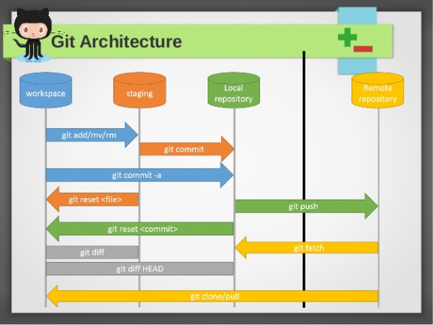

Installed the git.

Then create new folder with any name.

To make this folder as local repository we need to open command or git bash terminal.

To make normal folder as local repository we need execute the command as

git init inside this folder .git folder get created which hold local repository details.

Then create or delete or update the file inside a folder (local repository).

git status it is use to check the current status of local repository.

git add filename it is use to add the file or folder from local machine or workspace to stagging area.

git commit -m “message”

git config --global user.email "you@example.com"  
git config --global user.name "Your Name"

git config --global user.email [akash300383@gmail.com](mailto:akash300383@gmail.com)

git config --global user.name "Akash"

git branch : git branch is like a pointer which hold more than one commit details. Using branch we can do changes on code without effecting actual code.

By default git provided default branch master or main.

git branch : it is use to display all branches present in local repository

git branch A this command is use to create the branch

git branch B

git checkout branchname this command is switch from one branch to another branch

git merge branchName this command is use to merge the code into current branch

git branch -D branchName this command is use to delete the local branch

Remote repository : using remote repository we can share the code between one team to another team.

Github

Gitlab

Bitbacket

AWS

Azure

Or private cloud etc

git branch -M main this command is use to rename the branch

git add remote origin URL this command is use to link local repository with remote repository

git push -u origin branchname push the code from local repository to remote repository